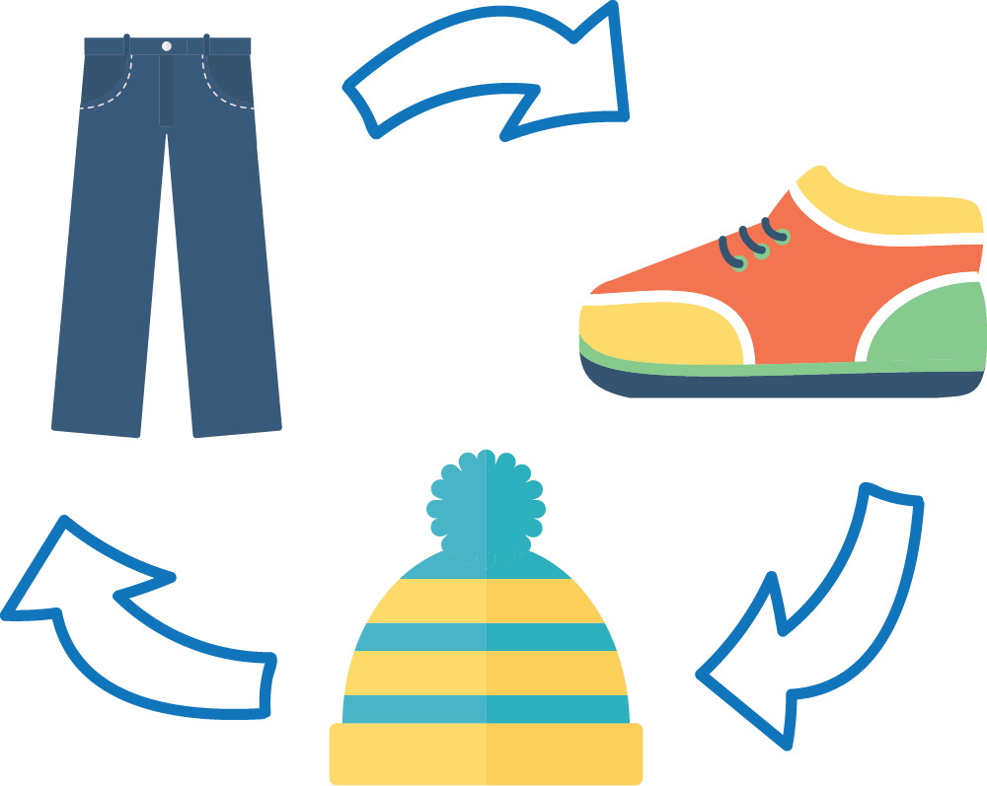
Swap Til You Drop in [COMMUNITY]
Did you know North Americans send more than 10 million metric tonnes of textiles to landfills each year, 95% of which could be reused or recycled? Let’s extend the useful life of our clothing for as long as we can!

To make an impact, [ENTER BUILDING, COMMUNITY, ORGANIZATION NAME] will be hosting a clothing swap in celebration of [WASTE REDUCTION WEEK IN CANADA OR OTHER EVENT].

Clothing swaps are a fantastic way to find new and unique items at no or low cost. They also allow you to meet people in your community you may have seen but never spoken to. Most importantly, swaps extend the lifecycle of clothes and materials, and reduces environmental impacts from making new items or disposing of used. That’s why [Community] is hosting our very own swap!

Bring gently used clothing, accessories, or small items in a reusable bag or box to [SPECIFIC LOCATION DETAILS] from [TIME] on [DATE]. For each acceptable item, you will be given one ticket to swap for something ‘new to you’.

What can you bring?
Acceptable Material | Not Acceptable Material
- Clothing  - Accessories: hats, mittens, scarves, ties, purses, wallets, backpacks, bags, jewelry, watches  - Small miscellaneous items: books, toys, games, puzzles, stuffed animals, pots, pans, utensils, vases, dishes, cutlery, glassware, silverware, stemware, jewelry, crafts, mugs, candles, picture frames, baskets, ornaments, hand tools, media, small furniture, small appliances | - Other textiles: bed/bath towels, sheets, blankets, pillows, curtains, tablecloths  - Large miscellaneous Items: large appliances, large furniture

The Swap It Toolkit is a project of Recycling Council of Ontario, supported by the City of Toronto through its Waste Reduction Community Grants.

We look forward to seeing you there! For more information please visit [YOUR WEBSITE IF APPLICABLE] or feel free to contact me,

Sincerely,
[ORGANIZER CONTACT INFO]

